 [](https://www.google.com/url?sa=i&rct=j&q=&esrc=s&source=images&cd=&cad=rja&uact=8&ved=2ahUKEwjTvsqI44rfAhWEWX0KHaAVAcYQjRx6BAgBEAU&url=https://www.ncl.ac.uk/&psig=AOvVaw1Eq5O_O_ny89lCR4P0YfWZ&ust=1544170912596808)

**Bachelor of Engineering with Honours in**

**Mechanical Design and Manufacturing Engineering (MDME)**

MME3191 – Capstone Project

AY2021/22

Design of a compressible storage system

By Chew En Yu, 1901438

# acknowledgements

I would like to thank Professor Kyrin Liong and Steven Tay for their supervision and guidance through the project. In addition, the team from CGH, with Sister Azlinda, Kris, Hwee Li, and Karen, for their support and collaboration in the project.

# abstract

This study investigates the design of a compressible storage system. In some settings, it may be ideal that when not in use, a storage system may have its size reduced for its storage. This study develops on the design on one method for doing so using hinges and telescopic rails, then a prototype is built and evaluated. Many words were made regarding how the project may continue and what future work may be done.

Table of Contents

acknowledgements 2

abstract 2

1 introduction 4

1.1 Problem statement 4

1.2 aim 4

1.3 scope 4

1.4 structure 4

2 literature review 5

2.1 The current status 5

2.2 what constitutes a storage system? 6

2.3 what is needed to allow reduction in size? 7

2.4 what about shelf height adjustment? 9

2.5 mobility 10

2.6 prototyping structural materials 10

3 methodology 10

3.1 project design iterations 10

3.2 design breakdown 10

3.3 Design evaluation 11

3.4 limitations 11

3.5 Assumptions 11

4 Design 11

4.1 design 1st phase – initial concepts 12

4.2 design 2 – method of execution 13

4.3 design 3 – further establishment of design 14

5 discussion 15

5.1 Evaluation of final products’ performance 15

5.2 Future work 16

5.2.1 Design improvements and changes 16

5.2.2 A better representation of the current prototype 17

5.2.3 Production 17

6 conclusion 18

7 References 18

8 appendices 20

# introduction

This report covers the design and development of a compressible storage system.

## Problem statement

At a hospital’s operating theatre that runs all the time without stopping, a mobile storage system is used for storing inventory at pre-determined locations, as well as the transportation of inventory.

The Storage System needs to be sanitized daily at its place with the use of wipes, and a monthly deep cleaning via steam sterilization at another locale.

When the Storage System is moved for its monthly sterilization, there is a need for a replacement immediately. As such, there are spare replacement systems for this purpose.

These spare storage systems, which are not in active use, due to their size, require a large volume of space, and a storage room for their own storage. This is an inefficient use of this space

There is thus, a need for a more space efficient storage system, for when they are not in active use.

There is thus, a need for a storage system, which can be compressed into a smaller space when not in use.

## aim

Aim is to explore the design of a storage solution that is compressible.

Approach is to first investigate the existence of comparable products and mechanisms that allow compressing or a decrease in volume or length.

To then iterate through design while checking and evaluate with client on performance of design

Then to develop a prototype to be evaluated by the client to best showcase how it is to be interacted with, as because physical to scale models are easier to evaluate and conceptualize.

## scope

The scope of the study is limited to the structure and mechanisms of such a product, and how it can be previewed with a prototype.

There were considerations and research done for materials and choices, however, they were not taken into thoughtful consideration for the prototype

## structure

This writing follows through the purpose and contribution

* Evaluation of other or similar designs
* Methodologies, limitations, and assumptions made
* Sources of information
* Design iterations
* Analysis and evaluation of the resultant prototype
* Conclusions

# literature review

The literature review begins with a deeper study into the context, background, and current state of the storage system used by the client. Followed by a review of existing and relevant products and mechanisms that may solve for the problem statement. Lastly a brief review of available resources that may aid in solving the problem statement.

## The current status

How is the storage system to be used? What is the current state of the storage system? And how does it derive into the problem statement, i.e., how can its status be improved?

### How is the storage system used?

The storage system is used in a hospital setting, there are sanitation standards to be achieved. There are three acts to be performed, covering with a fabric cover when not actively accessed; daily sanitation using disinfectants that contain chemical solvents, and germicides; and weekly to monthly washing with hot 85 degrees C water and neutral detergent.

The storage system is mobile and is either used as a pseudo permanent storage at designated locations that require storage space, or for transportation of inventory. No specific storage unit is designated for a location or task, they are all in rotation. It is moved from this designated location for washing, where it will have its contents, if any, removed and passed onto a replacement unit, then moved to a washing facility, and to a storage facility. It will be moved out of the storage facility when it is its turn to relieve another unit of its duty.

The storage system stores a combination of metal containers and trays wrapped in fabric to keep its contents sterile, Appendix 2. The specifications of the inventory were measured and shown in Appendix 3

### What is the current state of the storage system?

The storage system has two forms of shelves, 1 is has an open, exposed wire shelving, the other is covered with a steel sheet. The height, depth, and length are 172, 60, 120cm respectively.

The system uses caster wheels for mobility. These have brakes that are engaged when the unit is at its designated locale.

The shelves are height adjustable, via a tool. The segmented vertical posts must be separated from the top down, until the shelf is reached. E.g., to raise the bottom most shelf, all segments of the vertical posts, and the shelves, must be removed, then a segment of the vertical post, may be moved from above the shelf to below the shelf, and the whole assembly reassembled.

The storage system is not compressible without complete disassembly.

### How may the current state be improved?

Due to the nature of the facilities operation, a storage system unit must always be present at designated locations, as such, there exists spare/buffer sets. Their incompressible nature means there is inefficient utilization of floor space.

Further, the requirement of a tool and the method of disassembly, makes shelf height adjustment impractical. As such, the utilization of the storage system is less than optimal, they are not height adjusted to best fit their varying inventory.

Lastly, the exposed wire shelves tend to damage the cloth wrapped inventory.

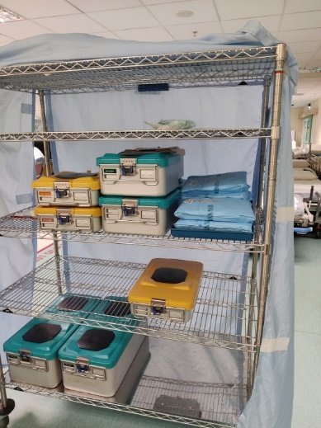

Figure 1 photo of current storage system

### Safety and user interaction

With the concept of mobility and compressibility, there are, or will be, moving mechanisms. As such there needs to be a degree of consideration towards safety to avoid impingements.

Also, it should interaction should be intuitive, and fast. With priority given to how it is compressed and expanded. And secondary priority to shelf height adjustments.

## what constitutes a storage system?

It is a system with primarily a structure or a body that can carry or hold an inventory. The dimensions are height, depth, and length. The terminologies and marketing terms are mildly problematic, as there are numerous terms used by different companies, however, a single term is selected to be used in this paper for each. In addition, the chosen forms of storage system to study should be mobile or have the potential to be made mobile.

With the current storage system, Figure 1 photo of current storage system, referred to as a shelving unit, consists of 4 vertical posts, with multiple flat horizontal shelves.

There is a similar storage solution as well, see Appendix 4, the Worktainer, typically consists of 1 or 2 shelves and have 3 mesh walls.

Finally, there are trolleys, Appendix 5, that differ from shelving units in that they may only have 1 horizontal surface for carrying inventory and are typically about waist height such that it is ergonomic to push about. This horizontal surface may be kept low to the ground or extended upwards.

Evaluating the 3 mobile storage systems, they do present potential structural and mechanical designs that may be considered. To use as design inspiration for the main structure, more than likely the shelving unit, and Worktainers are more suitable.

## what is needed to allow reduction in size?

Compressibility, according to the oxford dictionary refers to the capacity of something to be reduced in size with pressure.

There are mechanisms necessary for this compressibility. A review of products with such capacity finds primarily folding hinges, pantographs, and telescopic features.

Folding hinges especially seen in Worktainers, allows the system to fold into a smaller space, as well as a convenient method to stack multiple units together so they collectively take a smaller space. some designs also utilize a tapered or slanted geometry to allow stacking without folding, Appendix 6.

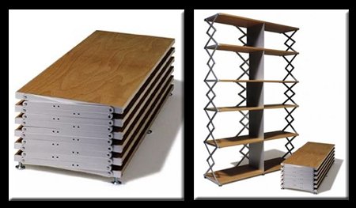

Figure 2 pantograph shelving [1]

Pantographs use a linkage structure that allow for extension and compression, pantograph shelving, Figure 2, allow for the entire shelving unit to be compressed down to nearly the total thickness of the shelves.

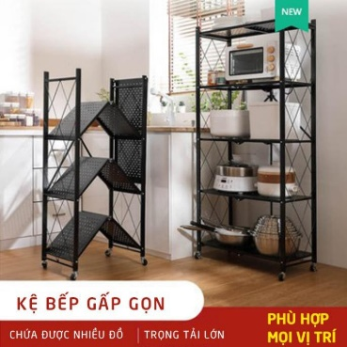

Figure 3 folding storage shelf [2]

The linkage structure can also be rotated, and instead of a vertical compression, be horizontal.

|  |
| --- |
|  |
| Figure Table trolley [3] |

Telescopic features, such as Figure 4, allow for extension as well, like how the pantograph mechanism does so, however with more orthogonal stability. There are multiple forms of telescopic extension mechanisms, they typically involve rails of sorts, and at times contain bearings for smoother motion.

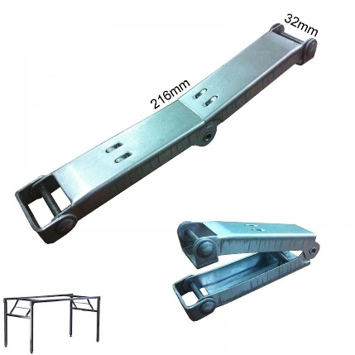

Figure 5 folding table spring hinge [4]

On a mild tangent to compressible mechanisms, akin to folding hinges, there are also folding tables. These are designed to fold and extend, and when extended, be locked in place and brace loads. A notable design is the hinge in Figure 5, the axis of the load is offset from the hinge’s axis, thus it creates a turning moment that pushes towards the direction of extension, thus bracing the hinge, and keeping it extended rather than collapsing.

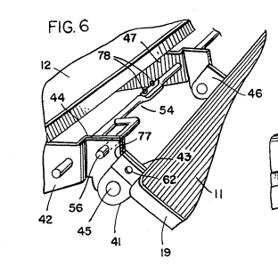

Figure 6 folding table lock [5]

Another method to lock the hinge, or any movement, is using a pin.

An evaluation of these existing products, the mechanisms using linkages, Figure 2 and Figure 3, are both not height adjustable, as the bracing mechanism is attached from one shelf to the next, thus there is a pre-determined distance from shelf to shelf. The folding hinge of the Worktainer presents a potentially neat solution, as both the shelves and frame fold away to compress the whole product. the telescopic mechanisms present well orthogonal robustness, which may be considered.

## what about shelf height adjustment?

Figure 4 using vertical telescopic mechanisms allow for height adjustment however of only one shelf.

Varying height, segmented vertical posts such as the one in current use is also available.

Lastly, Appendix 7, using a frame with indexing holes and pins to set the height of shelves.

Of these, the segmented vertical posts have already received a negative evaluation. Using the telescopic mechanism, while there could be orthogonal robustness, it is not clear how more than 1 shelf could be used. this leaves the usage of indexing holes and pins for height adjustment. it can also be said that there could be a more continuous solution rather than indexed holes at equal spacing.

## mobility

Caster wheels have numerous forms [6]. The current storage system uses ones that may swivel and have stoppers that prevent wheel movement. To achieve the same mobility, a caster wheel with the same, or similar features should be used.

In addition to these features, there are also various caster mounting solutions, such as plate mounts, post mounts. They have dimension specifications and loading ranges per wheel. For this study, the above stated specifications should be well considered, as they directly affect the representation of the caster wheel’s function.

## prototyping structural materials

There are various prototyping materials, or rather, materials that offer modularity and easy of change. Materials such as these allow for design changes and reusing the same materials for other designs or other projects entirely. As such, it should be sought after that material used be modular, and of the same form factors. Misumi [7] will be the source of literature for many of the materials, however they may not be the supplier.

To begin, aluminium profiles make for a good structural prototyping material. Their modularity allows for ease for changes to design, and a more relaxed need for tolerances. Suppliers are able to cut the profile lengths to relatively good tolerances. There exists numerous mounting and joining solutions to an aluminium profile system, such as pre and post assembly profile nuts, or angle brackets.

# methodology

A few methodologies are used to guide and constrain the project. These methods are followed through the project.

## project design iterations

An agile sprint methodology was used to guide and structure the progress of the design.

Each sprint phase having increasing elements that brought the design closer to its physical iteration.

Within each phase, consists of simply of:

* An information gathering phase of either literature review or planning. However, this was not necessary for every phase.
* A design phase where the information from before is consolidated into illustrations either within CAD or sketches.
* Then an evaluation phase, of the produced design(s). finite element analysis is done. In addition, as there is a clientele, the evaluation is done with them.

## design breakdown

The design is broken down into key components to reduce design complexity.

In the initial planning phase, the key components are the frame and shelf. In addition, there is a need for a mechanical interface to join the shelf to the frame. And a mechanism that allows the frame to be compressible, and the shelf to be contained or compressed with the compressed frame. Lastly, the design should allow the full assembly to accept load in the expanded state.

There are additional components that would arise from these pre-determined components, as well as other critical components that do not require significant design considerations that would be mentioned only in passing.

To summarize, the key components and mechanisms:

1. Frame structure
   1. Frame compression mechanism
2. Shelf structure
   1. Shelf compression mechanism
3. Shelf-frame interface

## Design evaluation

The client would evaluate and choose the design choices to further develop on.

This does simplify the design evaluation. However, the client is not engineering inclined, and as such, the designs must be internally evaluated first, and have their potential, and features be presented to the client.

## limitations

There are budget limitations to the project, this limited the full scope of the project, both in scale and functionality.

Considering this, the materials used would be towards modular side. Namely aluminium profile systems. This modularity ensures ease for the future modifications to design, especially so for if there is a continuation of the project. This may not necessarily be cost effective in budget utilization; however, it would aid in project continuation.

In addition, the design of the project would be targeting the upper limits of the budget, taking care not to overextend and cloud evaluation of the project’s current state with what may be the design’s potential.

## Assumptions

This project was done with the assumption that there would be a continuation. To reiterate once again, that the project ends in an incomplete state, that allows for a future continuation.

# Design

The design goes through 3 phases before the parts are purchased and built. Each design phase iterates on the previous.

## design 1st phase – initial concepts

This first sprint phase primarily focuses on conceptualizing and evaluating mechanical movements that may allow for compression.

The frame compression mechanism is ideated first, then a suitable shelf compression mechanism is paired with it.

The inspiration for the mechanisms takes after the literature review.

There are 2 main methods for frame compression observed after the literature review.

The first is utilizing folding hinges like Worktainers. However, this constitutes a need for a method to store the shelves away when the frame is collapsed. A proposed solution would be to have the shelves be stored away like roof shingles on the side of the frame, or have the shelves be stored separately. In addition, this necessitates a need to assemble and disassemble the shelves with each compression/extension of the storage system.

The next, is to have an extension mechanism like Figure 3, where the frame’s walls are able to move towards and away, parallel to each other. This could be done using linkages like the pantograph, or with slide rails. This would then necessitate the shelves’ design to compress, allowing the frame walls to move towards each other. And in addition, for some form of bracing mechanism, to support the shelves when in the extended position.

Lastly, for a shelf-frame interface, naturally from the literature review, it could be either using a mesh structure on the frame, like the Worktainer, with hooks of sort on the shelves; or pin connections that are temporarily inserted into the frame, creating the support for the shelves.

To better illustrate how such mechanisms may work, brief prototypes were made.

|  |
| --- |
|  |
| Figure worktainer like shelf-frame interface |

Figure 7 illustrates how a shelf-frame interface using the mesh structure may allow for shelves to be stored like roof shingles, where they overlap the other

|  |  |
| --- | --- |
|  |  |
|  |  |
| Figure a linkage structure with a lock | Figure a spring-loaded linkage structure that braces when extended |

2 different forms of linkages, Figure 8 and Figure 9, that may be used, allowing extension, and collapsing, while also providing bracing when extended to take on loads

To summarize, there are 2 major ideas. With different ways of executing for each:

1. A folding frame using hinges, and shelves that can be removed and may be hung on the sides of the frame like roof shingles.
2. An extending frame, using either linkages or slide rails. And shelves that are collapsible using likely linkages or a hinge. Or a combination of both.

After presenting the 2 ideas, and the different methods of execution, decidedly, an extending frame would be best suited. The shelves would be contained within, and the operation of collapsing and extending would likely be a single movement.

## design 2 – method of execution

With the initial concept decided, there now needs a decided mechanisms to execute the movements.

The key feature is its ability for 2 walls to be pushed together, making the system smaller, via decreasing its footprint.

There needs to be a way for the 2 walls to move towards each other, likely while sustaining orthogonal stability. And a method for the shelves to be able to collapse together with the frame. Lastly, the structure would need to be rigid and robust when deployed to suitably hold loads.

Taking inspiration from Figure 3, the shelves could be split into two halves and using hinges, or rather, rotating points, to achieve the movement. This would necessitate that the shelf-frame interface be able to rotate and allow the rotational movement of the shelf about this connecting point.

At this point, based on the geometry and dimensions, the midpoint of the shelves should be depth wise, as opposed to lengthwise in Figure 3, such that the amount of vertical space needed during this collapsing is minimized.

Now there needs to be a way to support the folding shelves. Linkages, or a supporting arm that is rigidly fixed to the vertical posts of the shelving unit. Linkages offer the possibility of further compression, as opposed to a rigid support arm, which will likely restrict the movement of the frame.

A design with linkages can be seen in Appendix 8. This same illustration also portrays how the frame and shelf compression would occur, sans the mechanism.

With linkages, the collapsing potential is much higher, as likely the remaining footprint would be restricted by only the thickness of the frame structure and shelf structure. Whereas, if using telescopic slide rails, the entire movement would be depicted by the rails, which offer from less than half its length to a third of its length of compression, i.e., a volume reduction of between ~0.5 to 0.3.

Upon further evaluation, the use of linkages however poses a safety concern, with an excessive number of separately moving parts that may cause pinching. In addition, it would be difficult to use just linkages and guarantee their orthogonal stability, posing a design risk of lack of stability or robustness that is yet to be foreseen.

With this, the design that moves forward would be one where the frames are joined with telescopic slide rails; the shelves are 2 halves with a hinge joining them, allowed to collapse and move upwards; the shelf-frame interface is a pin joint that allows the shelves to rotate about the joint; and lastly an introduction of a shelf support structure that is rigidly connected to the frame.

## design 3 – further establishment of design

The incorporating of prototyping materials and hardware into CAD drawings.

Static FEA is done as a simple sanity check to ensure the structural components can sustain their own weight as well as expected loads. This is to ensure that the design does not have any blatantly missed flaws in terms of its robustness, as well as to note down regions of interest.

Initial FEA shows good static loading results, able to sustain proposed loads. There are subsequently, 2 points of interest, the shelf-frame interface, and the shelf structure.

The shelf-frame interface consists of pin that bears against the frame and the shelf, and it is subjected to shear forces and bending forces, it is the region in the whole structure that is subjected to the most stresses. The bearing surface, on the frame is unfortunately thin and at an offset distance from the shelf’s bearing surface, this results in a larger than optimal moment arm, that exerts stresses on the aluminium profile, this puts the aluminium profile at risk of deformation, which would compromise the orthogonality of the pin, and thus prevent rotation of the pin, or the collapsibility of the storage system.

The shelf structure is a considerable long length that is only supported at its ends. This resultantly means the length is susceptible to deformation. With the proposed design, the shelf length is simulated to observe ~4.2mm of deformation, ~20% of the thickness of the shelf itself.

With the design validated and all design features decided, orders were made and the prototype, or the final product of this research is assembled. There were a few shortcomings that occurred due to budget limitation; however, they are minimal and did not invalidate the portrayal of the design’s concept. Herein lies the end of the project’s design.

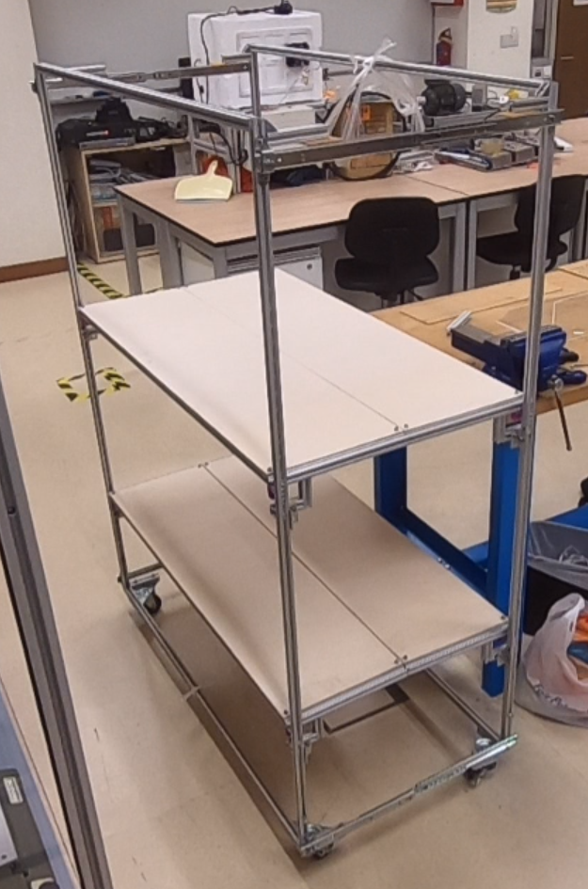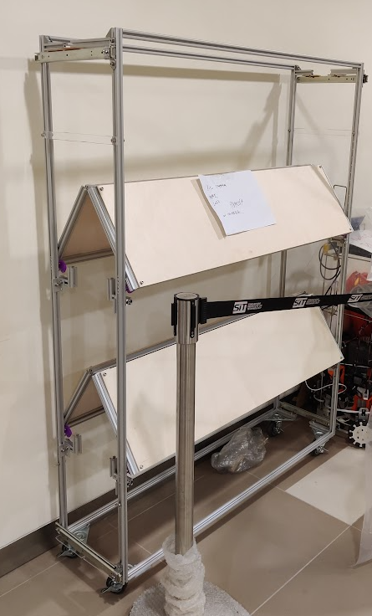

Figure photo of completed prototype

Appendix 9 to Appendix 13, shows the design components.

# discussion

## Evaluation of final products’ performance

No official or structured survey was conveyed, no note taking of personal information was done. This evaluation by the client was informal, and largely without verifiable evidence. However, these are general remarks that were made on the design and the physical prototype.

The resultant height, depth, and length dimensions are, 165, 60, 120cm respectively. When compressed, the depth decreases to 36cm, a 40% reduction in footprint.

The compressing mechanism shown by the prototype seems promising. The motion to compress was intuitive, and not complex, requiring only 1 step to begin compression, then then motion is unidirectional, simply pushing 2 walls together. It is simple, quick to be learned, and without requiring much force. However, this could be improved as with more shelves, it would require more personnel to compress the storage system.

There was a comment on the ease of pushing and moving the storage system as whole, as opposed to the current system. As it is not a complete product, there are some limitations to this judgement, such as the total combined weight, as well as the fatigue that would occur to the components after a period of usage. However, it could be discerned that the caster wheels chosen, which have smaller diameter, make acceleration of the storage system easier than the current system; and the lubricated bearings offer lower resistance. Thus, a perceived ease of movement. This should be noted for future works.

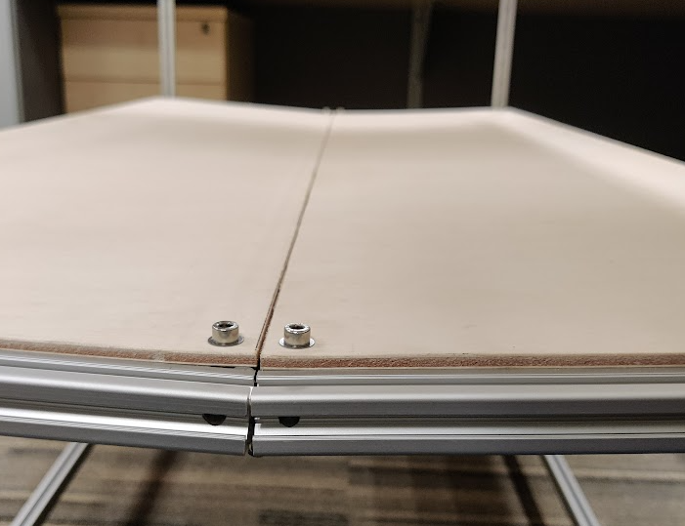

Figure photo of shelf sagging

Over time, and with dynamic loads from extending the storage system, the shelf supports would begin to slip, and resulted in the shelves not being supported to the appropriate height, as seen, Figure 11.

## Future work

### Design improvements and changes

Based on the evaluation, the design has regions for improvement.

Namely the mechanism that allows compression of the frame, the combination of the slide rails and the folding shelves. While it is deployed and the storage system is fully extended, it is not particularly rigid. By its current design, the structure providing the most stability are the shelves themselves. This consequently does not provide consistent rigidity and stability to the system. A brisk improvement would be if this extension mechanism was capable of being locked into a position while also providing some form of preload.

Another improvement to design could be again the frame extension mechanism, specifically the slide rails. they are the largest limitation to how much the storage system may be compressed. The extension mechanism could be revisited once again, perhaps by going back to the linkage design from prior, as it has the potential to bring the walls flush. Another method could be to utilize slide rails with more stages of extension, the current only utilizes 3, a 4 stage could potentially achieve 70% compression. Additionally, the slide rails’ purpose in the current state is to provide orthogonal stability to the structure and only during the translation from compressed to extended, a better telescoping feature could be sought after, such as cheaper telescoping aluminium profiles, a solution that does not require lubricants, or one with larger second moment of area or stiffness to provide greater stability.

During compression, the shelves require a user to start lifting the middle up, before being able to push the walls together. This is less than ideal, and it would require 1 personnel per 2 shelves.

Yet again, on the side of the shelf frame interface, the is a bracket used to hold the pin. The distance creates excessive bending forces, and the current design doesn’t offer sufficient support for the pin. A bracket that offers better support, lesser distance to the frame, and having either sufficient degrees of freedom or indexing features to ensure accurate location.

The shelf support is susceptible to slipping with the way it is currently assembled and affixed to the frame. The way it is structured, does not provide optimal transfer of loads to the frame as well. its geometry could be greatly improved, utilizing FEA to produce a better design.

### A better representation of the current prototype

The current prototype has comments regarding its user perceived robustness. There is a lot of play in many of the components. With the prototype, it was unfortunately decided to utilize m5 screws against oversized holes 6-9mm. The initial intension was to use larger screws or pins, however shortfalls with budget resulted in mismatched screws and holes. If these gaps and tolerances were filled up better, it would reduce the amount of play.

In addition, many joints that should not allow rotation, are only affixed by a single screw, which does not provide sufficient reaction forces to moment forces. For example, the slide rails are affixed to the frame with only 1 point of contact, this does not create sufficient orthogonal robustness, and the slide rail is very much so able to rotate around its joint. Another example would be the aluminium corner joints, the used form of bolt joint relies on the friction that is generated from positive and high fastening pressure from the bolt, an angle bracket would provide significantly higher affixion.

Caster wheels, despite a good evaluation, it is yet to be seen the future performance of the current wheels. The smoothest and ease of movement is likely attributed to the smaller wheel diameter and lubricated bearings. The smaller wheel diameter may be more optimal and should be considered for future iteration, the storage system is not used for transportation delicate or fragile items, the surfaces it runs on are smooth, this there isn’t a need for large diameter. This wheel dimensions may be better optimized. The caster wheel has exposed bearings, and with the frequent washing with water at temperature, the lubricant well is likely to be eroded away. A sealed bearing, a bearing without moving metal on metal parts, or steps to ensuring consistent maintenance should be considered. This same note on bearings and lubrication also applies to the slide rails used.

### Production

There are design changes to be made to bring the design to production and manufacturability.

The first, would be removal of many fasteners. Fasteners are used for the prototyping, again with its modularity with the aluminium profile system. Better solution should be sought after that reduces the quantity of parts.

Next would be replacing the aluminium profiles for the frame. There are 2 proposed solutions to this, and both arise from the need for washing the storage system. The utilization of either square steel tubing, with bushing inserts, Appendix 15; or U-shaped steel tubing sufficiently wide for brushing and wiping. In short, the solution is to either entirely seal the structure from water such that the internal structure does not need to be cleaned, or to fully expose it, and to ensure it is easy to be cleaned.

Another would be the shelving structure. Its design could be developed such as taking from Appendix 1, where trimmings and steel shafts are bent and welded together.

Greater consideration for materials and interfacing solutions. The current system, Appendix 1, utilizes chrome plated steel. This has worked well, however in regions, specifically the interfacing region of the frame to the caster, impacts have likely caused the plating to shed, and signs of rust has begun to show. For the design produced, there are moving mechanisms, that will create many regions where wear will occur. As such, these regions, if it were to be metal on metal contact, either to use corrosion resistant materials, such as stainless steels, brass, or plastics; or to use a corrosion resistant interfacing solution that will act as a sacrificial material to bear against the wear and tear.

Lastly, considerations for chosen components, tying in again the moving components, namely the slide rails and caster wheels, as well as including the shelf-frame interface. These components require movement, and it may be decided to use bearings, these bearings should they require lubricants, should be sealed, or maintenance be done about as frequently as washing occurs.

# conclusion

A design was done, and a prototype was built to best provide a representation of the design’s concepts. Having achieved a 40% compression. The primary mechanism that allows the compressibility is the half shelves that are able to fold, and the frames that are held together using slide rails.

The study does answer to a good degree how a compressible storage system may be built. These are simply the beginning stages to the design of such a system, and there more iterations should be made for the many different components of the design, some of which may be a project on its own. The performance and evaluation of the design though does appear good, and with eagerness to continue, the future possibility and viability of the design is yet to be seen and would require a few iterations before judgement can be made.

Some component designs require further improvement, and the likely largest hinderance to the viability of the project is the preparation for production and the cost of production. With the current prototype requiring the entirety of the budget, it is possible that for production, the costs would be too large to justify. Caution and consideration should be taken with the continuation of the project, especially so with cost of production.

# References

|  |  |
| --- | --- |
| [1] | Web urbanist, “10 Transformable, Convertible & collapsible Urban Furnitures,” [Online]. Available: https://weburbanist.com/2007/08/23/transformable-convertible-collapsible-furniture-for-cramped-urban-living/. [Accessed 2022]. |
| [2] | Shopee, “folding shelves,” [Online]. Available: https://shopee.sg/Folding-Shelves-Multi-Purpose-Storage-Shelves-With-Wheels-To-Move-i.503612627.3497156593. [Accessed 2022]. |
| [3] | hoffman group, “Table trolley with height-adjustable platform,” [Online]. Available: https://www.hoffmann-group.com/GB/en/houk/Workstations-and-storage/Roller-cabinets-and-transport-systems/Table-trolley-with-height-adjustable-platform-TA9/p/918557. [Accessed 2022]. |
| [4] | Chee Kuan, “banquet folding table spring hinge,” [Online]. Available: http://www.cheekuan.com.my/index.php?ws=showproducts&products_id=2289670&cat=Banquet-Folding-Table-Bracket#openproducts. [Accessed 2022]. |
| [5] | F. F. Mueller, “Combination safety stop and down lock for folding tables”. United States Patent US4027600A, 1976. |
| [6] | Misumi, “Misumi digital catalog,” [Online]. Available: https://sg.c.misumi-ec.com/book/en_sea_2014_msm_fa_02/digitalcatalog.html?page_num=2-1077-2014. [Accessed 2022]. |
| [7] | Misumi, “MISUMI South East Asia,” [Online]. Available: https://sg.misumi-ec.com/. [Accessed 2022]. |
| [8] | Metro, “Super Erecta Products,” [Online]. Available: https://metro.com/shop/super-erecta/. [Accessed 2022]. |
| [9] | Prestar.jp, “Worktainer,” [Online]. Available: https://www.prestar.jp/english/products/worktainer.html. [Accessed 2022]. |
| [10] | workplacestuff, “Adjustable height trolley,” [Online]. Available: https://www.workplacestuff.co.uk/product/adjustable-height-trolley/. [Accessed 2022]. |
| [11] | Medicalexpo, “loading trolley,” [Online]. Available: https://www.medicalexpo.com/prod/goldsworth/product-96087-657315.html. [Accessed 2022]. |
| [12] | richmond, “roll cages,” [Online]. Available: https://www.richmondau.com/product-category/roll-cages/. [Accessed 2022]. |
| [13] | Ikea, “Ivar,” [Online]. Available: https://www.ikea.com/sg/en/p/ivar-shelving-unit-pine-s49251346/. [Accessed 2022]. |
| [14] | matrix fitness, “Mega power rack,” [Online]. Available: https://www.matrixfitness.com/eng/strength/racks-and-platforms/mg-mr47-mega-power-rack. [Accessed 2022]. |

appendices

1. Current Shelving system

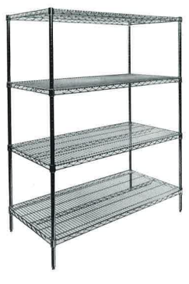

Figure 12 Image of storage system used by CGH, from supplier [8]

1. Current inventory

|  |  |
| --- | --- |
|  |  |
| Figure photo of Tray wrapped in fabric | Figure photo of steel container |

1. inventory specification and loading analysis

Table 1 inventory loading



There are 12 identified inventory types. Labelled 1-12. Their dimensions and mass were measured.

Their respective footprint area density are calculated, and the pressure they exert as well.

Finally, a stacked pressure is calculated. It is the total maximum load in N/m3 and kg, the specific inventory item can exert on a 1200mm x 600mm shelf, if it were to be stacked and packed onto the shelf with x amount of vertical space.

This was used as an initial gross overestimation of the maximum potential load that can be exerted on the shelf with the inventory on hand.

1. worktainer

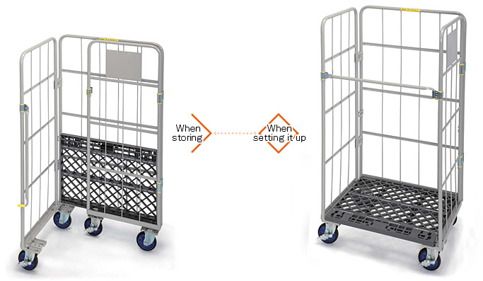

Figure 16 worktainer [9]

1. adjustable height trolley

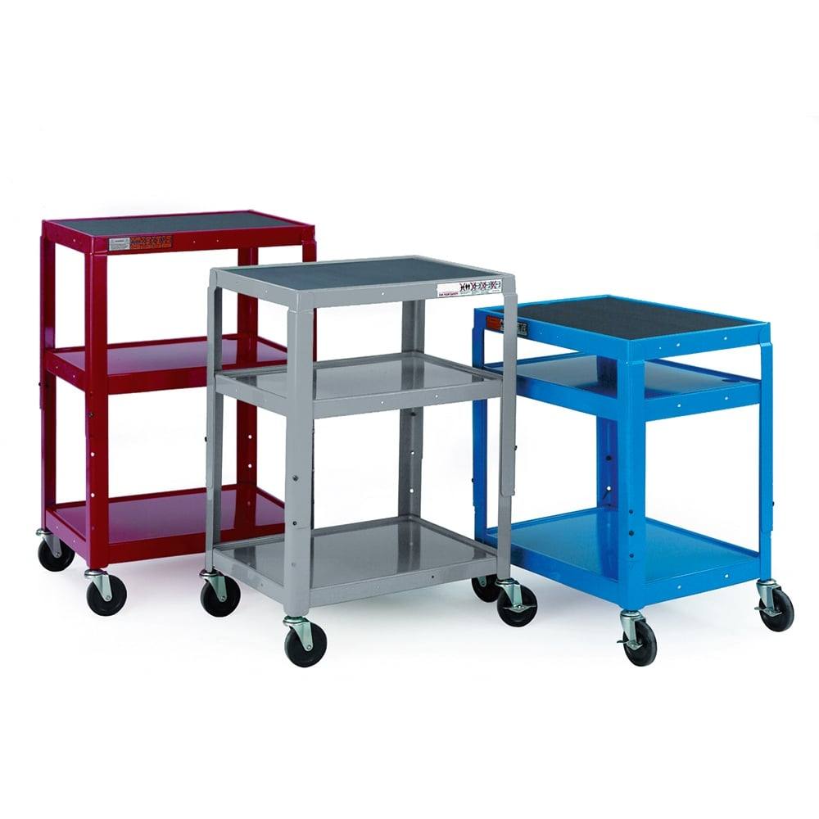

Figure 17 Adjustable height trolley [10]

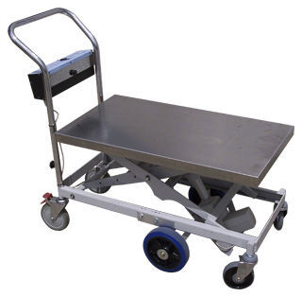

Figure 18 Loading trolley [11]

1. roll cages stackable

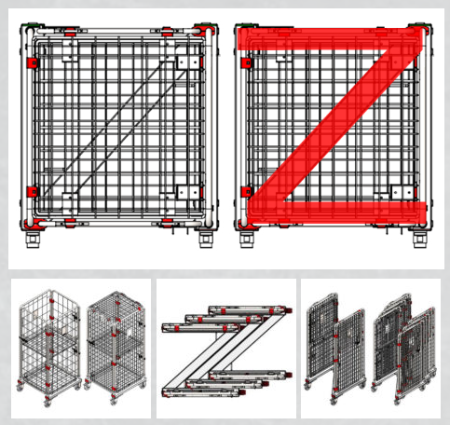

Figure 19 roll cages [12]

1. Ikea ivar system

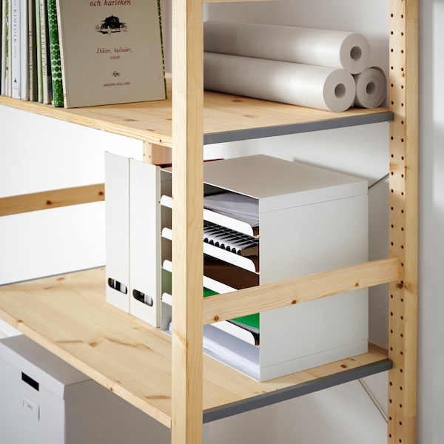

Figure 20 Ikea Ivar [13]

The Ikea Ivar system uses holes that accept metal pins.

The shelves have a metal sheet that rests over the metal pins.

1. linkage frame and linkage shelf collapsing

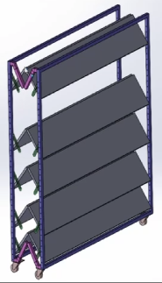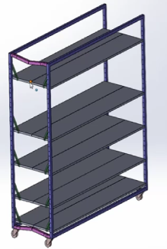

Figure 21 linkage frame and linkage shelf

This structure, an initial draft, uses linkages as the collapsing mechanism.

The frame has 2 walls, with linkages at the corner to join them together. This keeps the frame walls parallel to each other and provide rigidity in the extended and retracted positions.

The shelf-frame interface is a pin joint, allowing the shelf to rotate around this joint.

At the midpoint of the shelves, a hinge is used to join the 2 shelf halves. This allows the shelves to collapse with the frame.

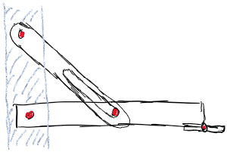

Figure 22 shelf linkage support structure

A support linkage is used to support the shelf half when extended. This linkage is allowed to slide up and down a pin joint that is fixed to the shelf.

1. Design of the product

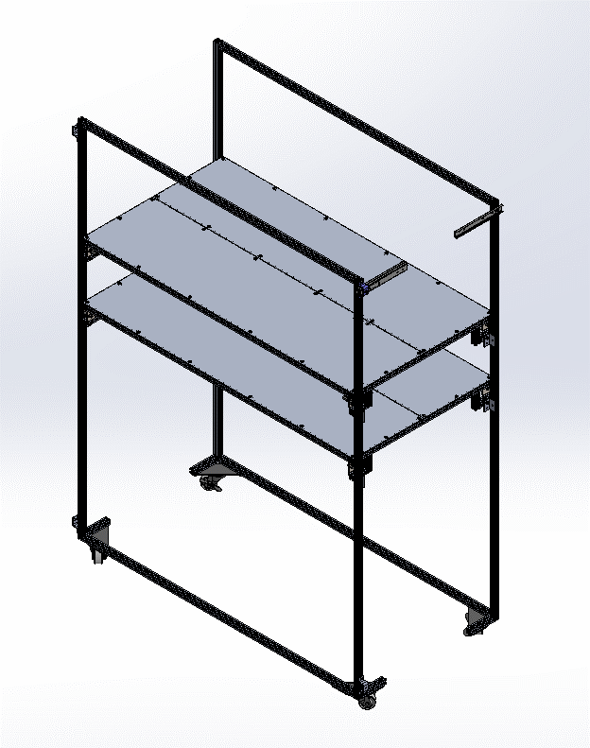

Figure CAD and photo of completed prototype extended

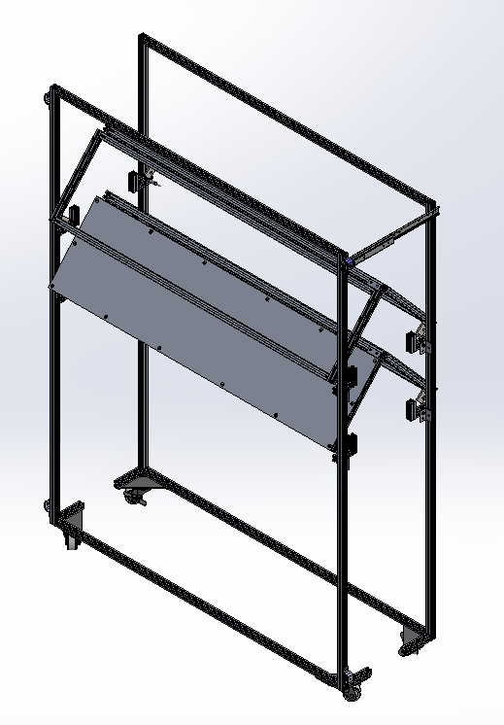

Figure photo of completed prototype compressed

1. Shelf design

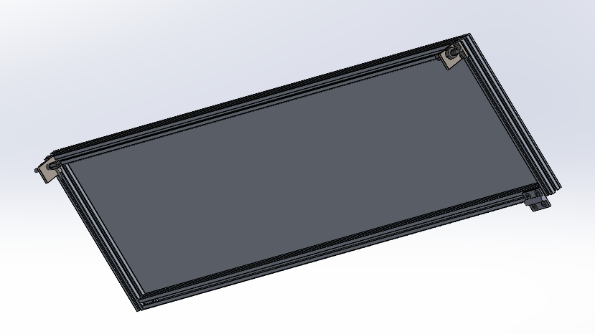

Figure shelf structure from underside

The structure is kept simple to reduce amount of hardware needed, and cost.

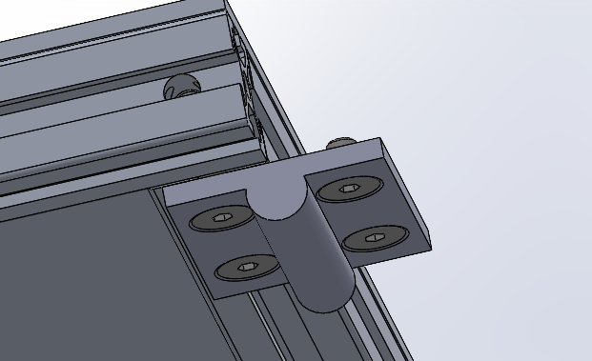 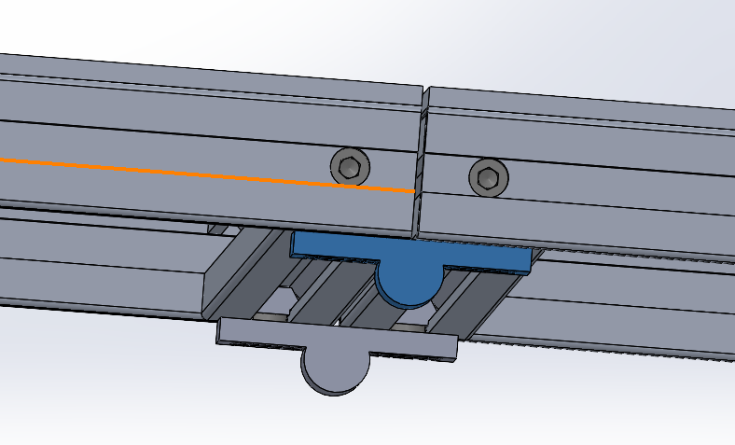

Figure shelf hinges

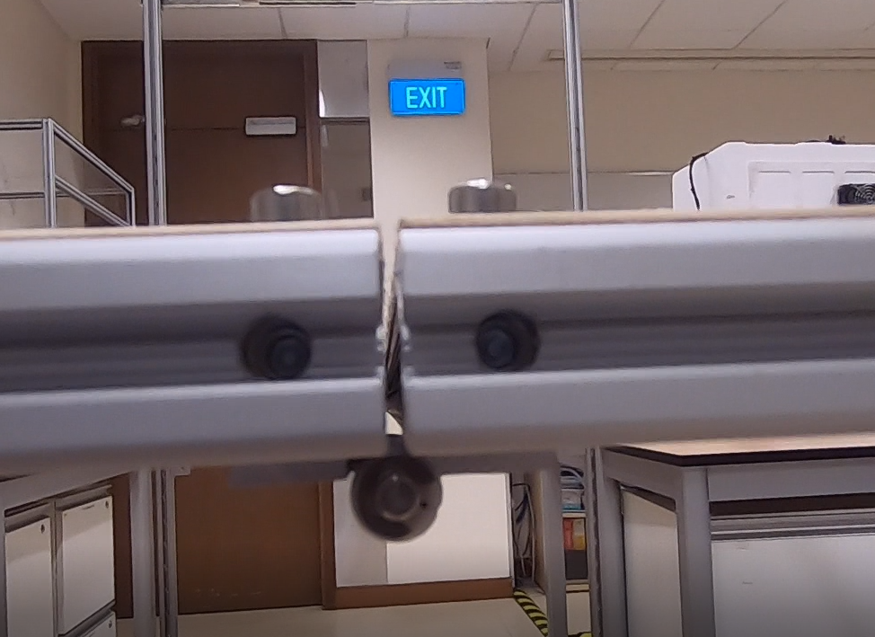 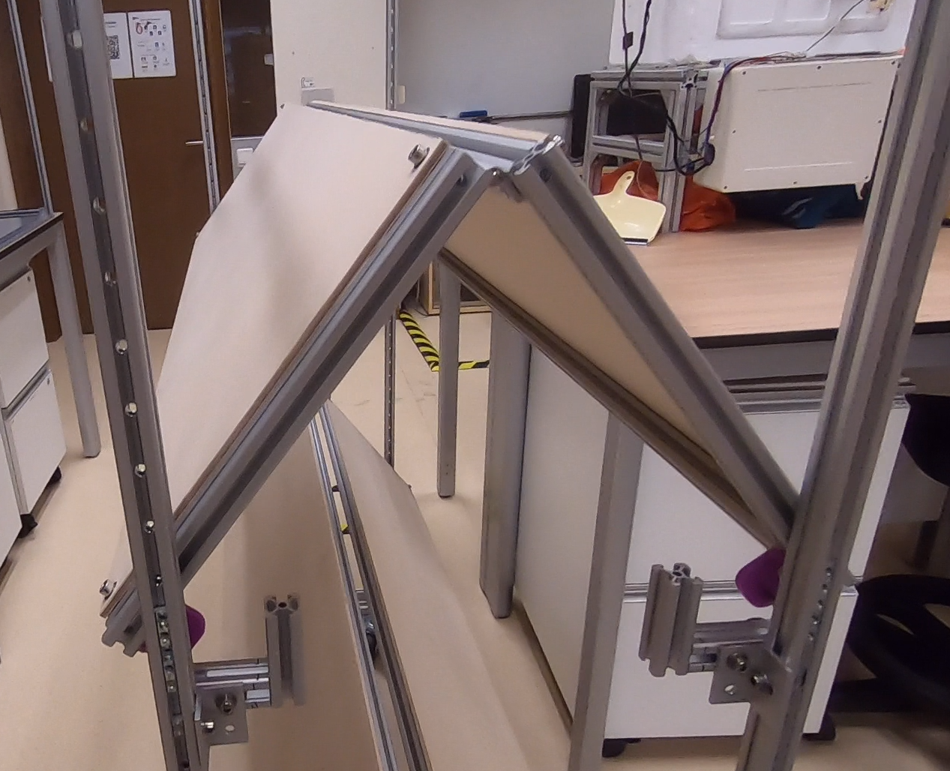

Figure photo of shelf hinges

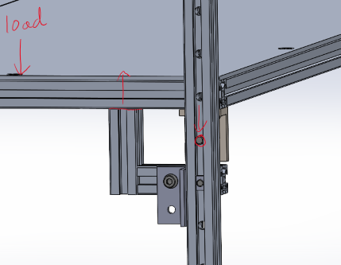

Figure shelf static loading FBD

To achieve the folding of the shelf, hinges at the ends are used to join the two halves of the shelf. The shelves are to be supported by the shelf-frame interface and the shelf support structure; thus, the hinges are not subjected to forces from loading and loads should be as seen in Figure 28 shelf static loading FBD

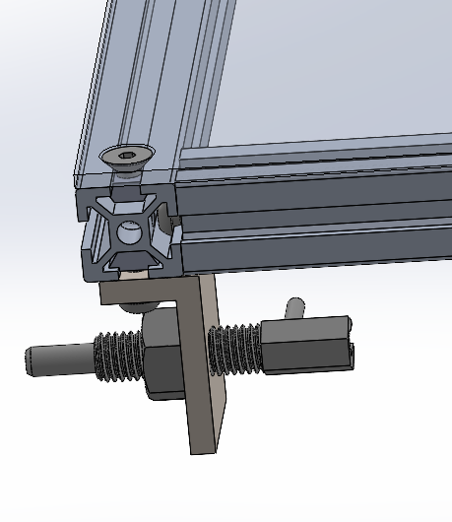

Figure shelf bracket for shelf-frame interface with index plunger

The bracket supports the index plunger at a distance from where the frame would be, this is an unfortunate design compromise, and imbues excess forces on the shelf-frame interface, the index plunger. The use of the index plunger allows ease of changing the shelf’s positioning, by pulling the plunger, the shelf is released from the frame.

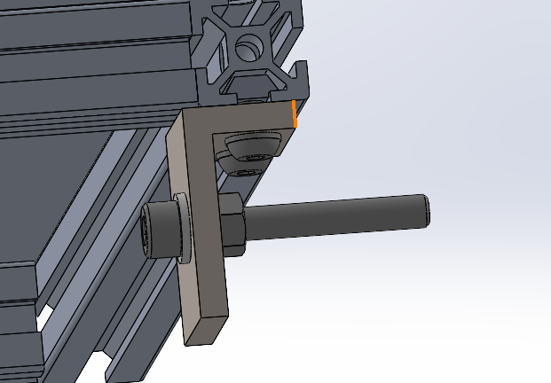 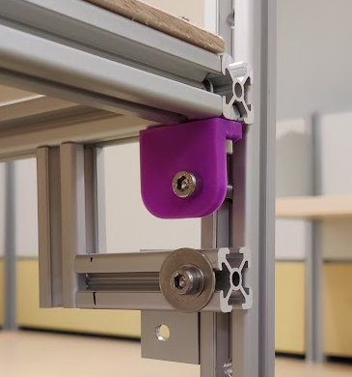

Figure shelf fixed bracket solution

However, it was anticipated there could be issues with achieving the indexing plunger with the physical parts, and a design was also made for the use of a fixed pin.

The shelf-top is joined using profile nuts and screws. In the prototype, the countersunk screws are replaced with bolts, and the length of the shelf-top is reduced for cost.

1. Shelf support design

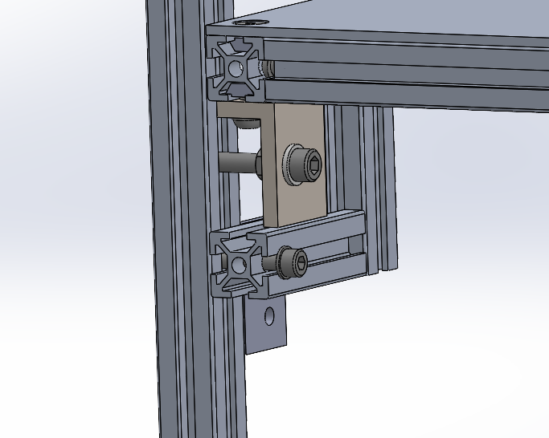 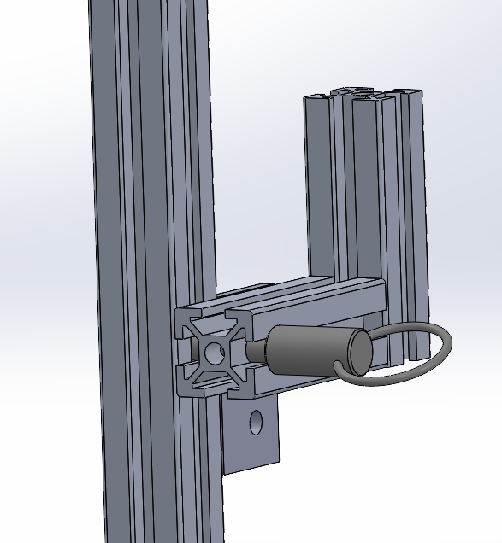

Figure Shelf support with fixed pin and removable ball lock plunger

Shelf support is made with two aluminium profiles and an angle bracket.

The vertical offset distance is so that the shelf has enough space for its rotation.

The angle bracket is to provide greater reaction forces to turning moments.

Ideally, the shelf support is to be removable and adjustable without use of tools, thus a design with a ball lock plunger that may be removed with ease but would not fall out on its own due to its spring-loaded ball pins.

There is a distinctive left and right shelf support, and they are simply mirrors of each other.

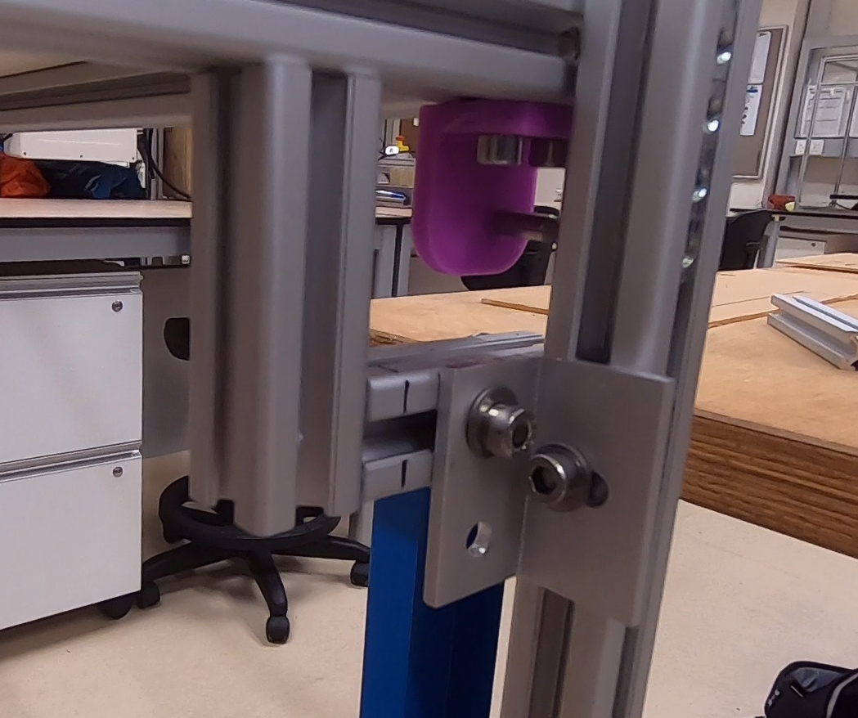

Figure photo showing angle bracket and shelf support

The angle bracket is affixed to the shelf support with a single screw.

The angle bracket has a hole such that it may be screwed to the frame’s vertical profile, this was made with consideration to how the angle bracket was fixed to the rest of the shelf support. By using a single screw, it may not be sufficient to resist turning moments, thus, should that happen, it may be screwed to the frame as well. However, this greatly reduced the adjustability of the shelf support.

1. Shelf frame interface design

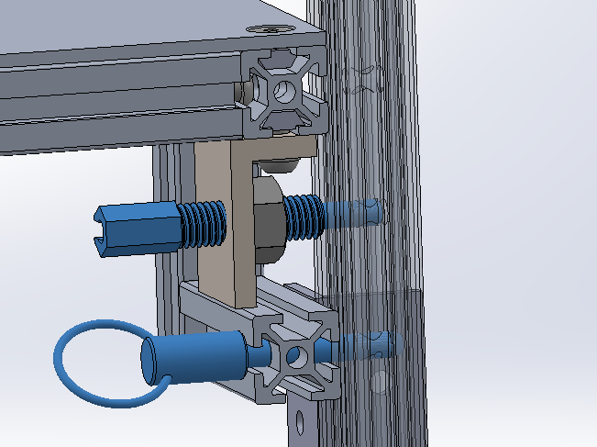 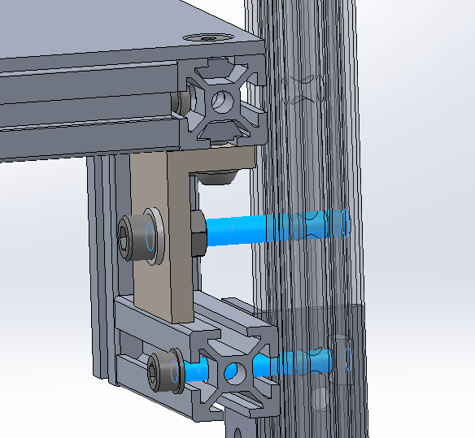

Figure shelf frame interface using removable plungers and fixed

Again, here shows the shelf-frame interface.

The pins enter the frame and bear against a hole in the frame.

1. Frame design

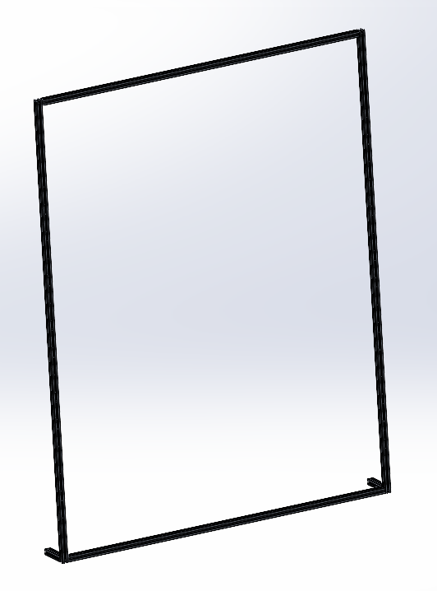

Figure frame aluminium profiles

The structure of the frame uses simply aluminium profiles.

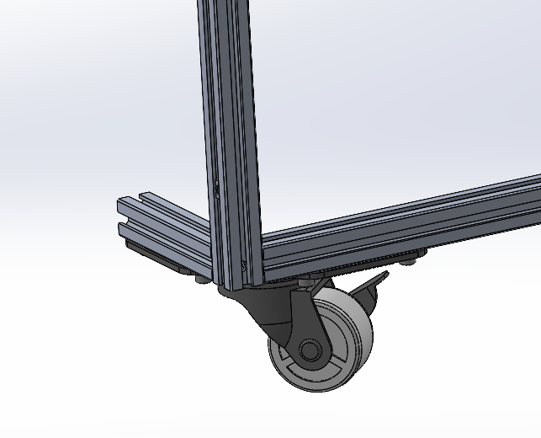 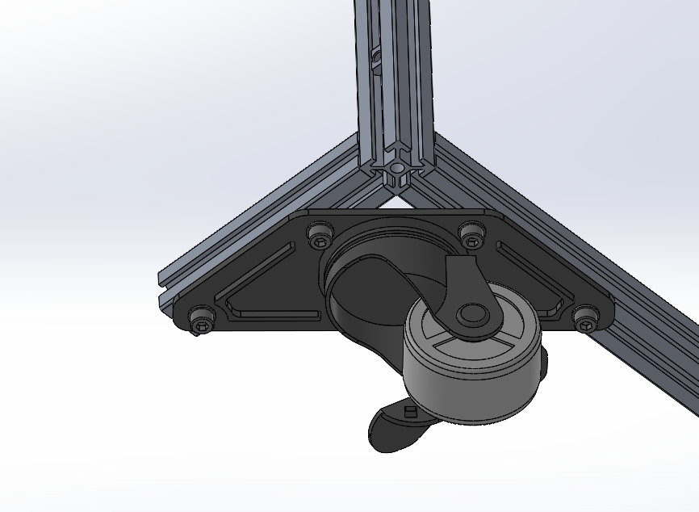

Figure frame caster wheel

The caster wheel chosen is one for an angle structure, as such, an additional aluminium profile is added to affix the caster wheel.

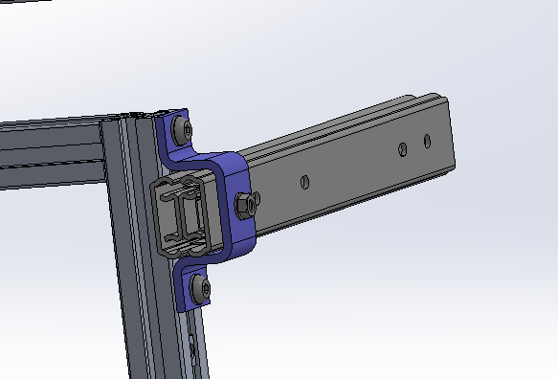 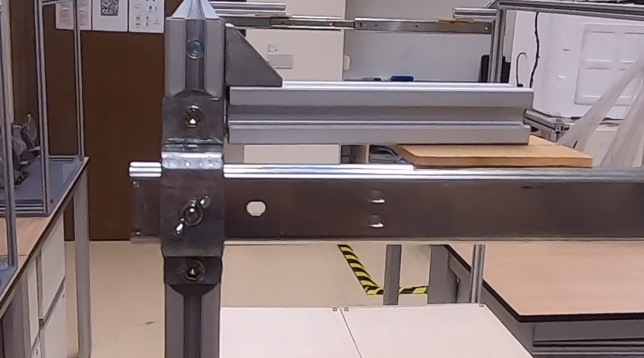 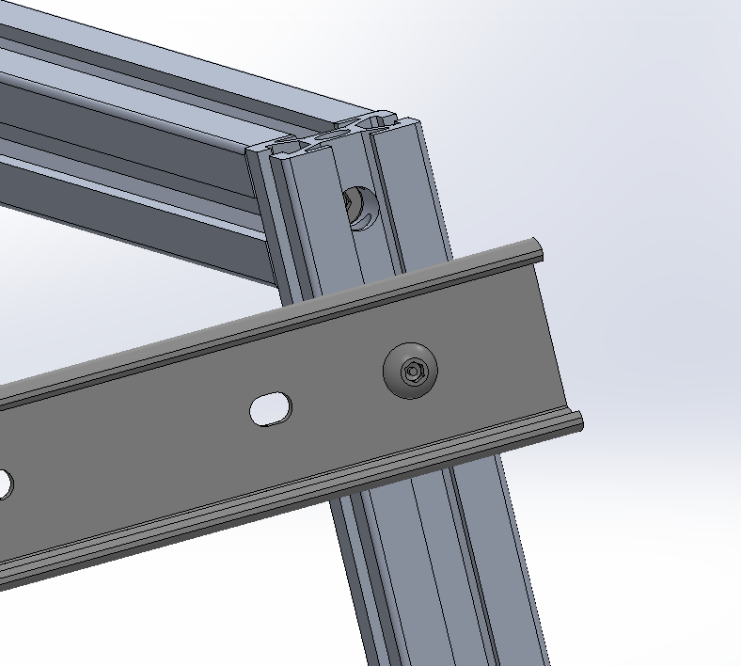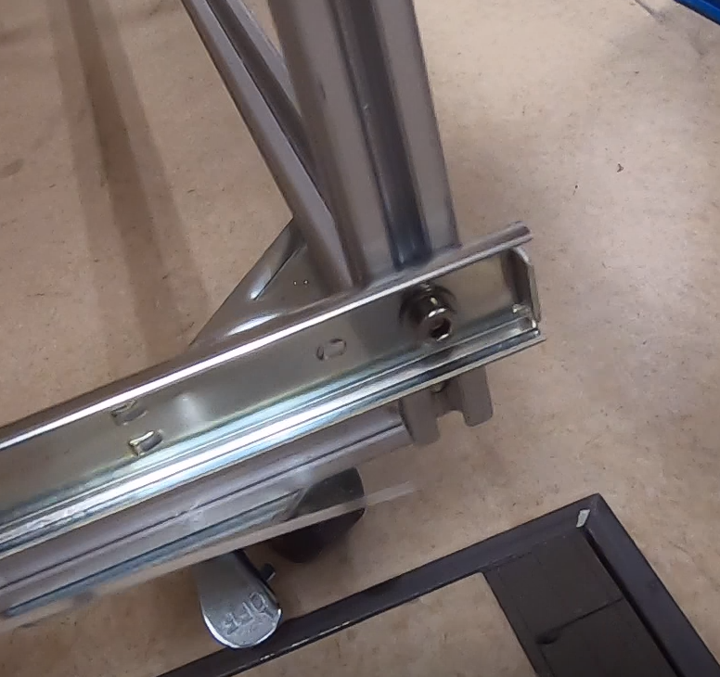

Figure bracket for telescopic rail

A bracket is used to affix 1 end of the telescopic rail. The other end is affixed directly to the frame without need for a bracket.

1. Finite element analysis

# Loading conditions

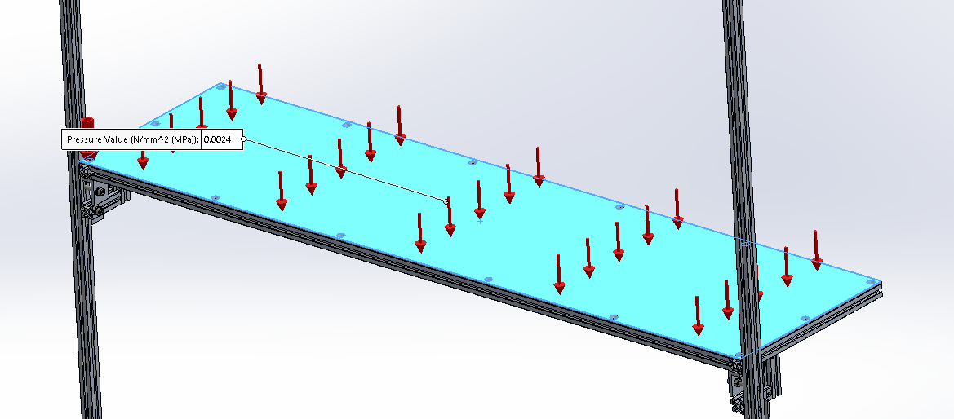

Loading is a pressure load of 0.0024N/mm^2, simulating a load of ~160kg, 2x expected load.

## Boundary conditions

|  |  |
| --- | --- |
|  |  |
| Figure shelf-frame interface frictionless contacts | Figure Ends of frame vertical profile is fixed |

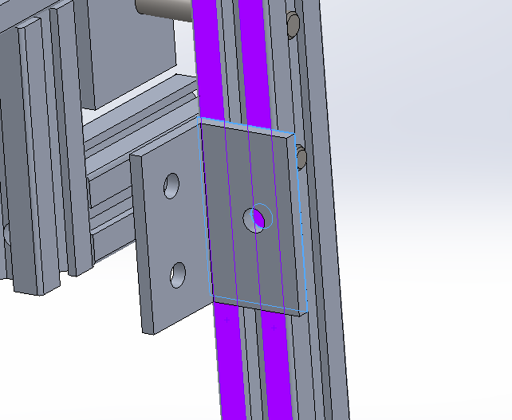

Figure frictionless contacts between shelf support mechanism and frame

All sub-assemblies are bonded together.

* Shelf support mechanism
* shelf

Sub assembly-sub assembly interfaces are frictionless contacts. Especially so for the shelf-frame interfacing pins.

The ends of the frame’s vertical posts are fixed.

Materials used are aluminium, and steel for all fasteners and hardware.

## Results

|  |  |
| --- | --- |
|  |  |
| Peak deformation at 8.2mm | Stresses below yield stress, approximately 5% below, at 1.9*10^8 N/m^2 |

## Comments

Deformation is high. Structure will not yield.

Good results, and sufficient to prove that design and structure with chosen prototyping materials will not yield. There aren’t design issues that would result in excessive stresses in any region.

Regions of higher stress are the shelf-frame interface pins that are subject to high moment forces, due to sub-optimal design.

1. future work

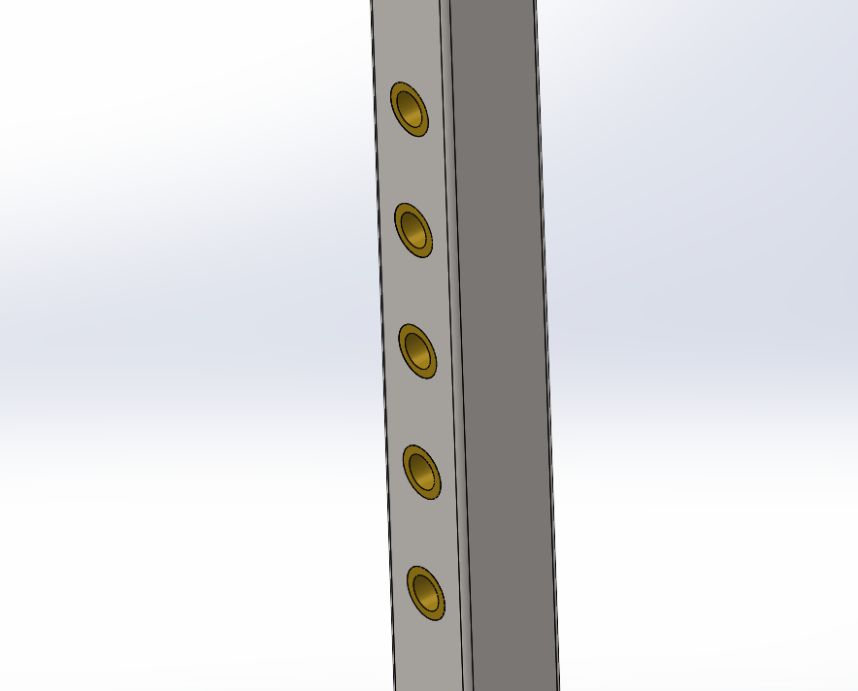 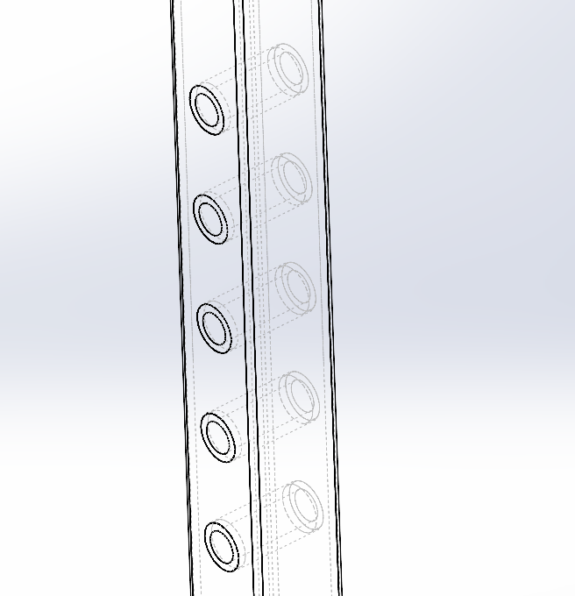

Figure square tubing with bushing inserts